profiling hydrochemical dynamics in a rain-dominated water supply area: characterizing the Leech watershed using passive sampling techniques

DRAFT – NSERC forWater Pacific Maritime Masters Thesis Project

Hannah J McSorley

2019-11-11

Table of Contents

Acronyms 3

Acknowledgements 5

Introduction 7

Source water quality and rain events 7

Stormflow and sampling (including passive sampling techniques and advantages) 7

Disscolved organic carbon and water treatment 7

Dissolved organic carbon and other parameters 7

Greater Victoria Regional Water Supply System 7

Research area: Leech River Watershed 9

Research Objectives 10

Research sites 12

Sampling Methods 17

Vertical racks for passive water sampling on the rising limb of hydrograph 17

Theory 17

Design 17

Benefits, challenges and assumptions 17

Field protocol 17

Method QA/QC: rising limb sampler quality assurance and quality control 17

Development of a passive water sampler design for the falling limb of hydrograph (falling limb sampler) 17

Theory 17

Design 17

Benefits, challenges and assumptions 17

Field protocol 17

Method QA/QC: falling limb sampler quality assurance and quality control 17

Analysis 18

In the field: gauging streamflow 18

Cross-sectional area and velocity 18

Manning’s equation 18

Salt dilution 18

In the laboratory: measuring water quality parameters 18

Quantitative analytical methods for dissolved organic carbon 18

Qualitative analytical methods 18

Ancillary data: contributions from partners 18

Results & Discussion 19

Spatial variability: DOC variability across the watershed 19

Synoptic grab sampling at ten locations 19

Stormflow samples: compare and contrast six sites 19

Temporal variability: DOC variability over time and within stormflow 19

Seasonal patterns over sixteen months of data 19

Stormflow samples: variability within six sites 19

Conculsions 20

Characterizing the Leech Water Supply Area 20

Understanding spatial and temporal variability in hydrochemical dynamics 20

Future Directions 21

APPENDIX 22

forWater: NSERC Strategic Network for forested drinking water source protection technologies 22

References 24

## Acronyms

|  |  |  |
| --- | --- | --- |
| Acronym | Term | Definition |
| NOM | natural organic matter | diverse carbon-based compounds found in natural, engineered, terrestrial and aquatic environments |
| DOM | dissolved organic matter | organic compounds operationally defined as finer than 0.45 um in diameter |
| DOC | dissolved organic carbon | organic carbon compounds operationally defined as finer than 0.45 um in diameter. The majority of DOM is DOC. |
| NPOC | non-purgeable organic carbon | instrumental parameter measured to quantify organic carbon (e.g. on a Shimadzu TOC-V analyzer). An aqueous sample is acidified to below pH 2 to convert inorganic carbon (e.g. carbonates) to carbon dioxide (CO2), the sample is then sparged with hydrocarbon-free air to drive off CO2, then the sample is combusted at high temperatures to convert the remaining organic carbon to CO2 which is detected with a non-dispersive infrared gas analyzer. |
| DBP-FP | Disinfection By-Product Formation Potential | The likelihood of creating DBPs(e.g. trihalomethanes, halogenic acetic acids, Haloacetonitrils, haloketons) when natural source water is chlorinated |
| LWSA | Leech Water Supply Area | Future water supply area anticipated to supplement the primary water supply (Sooke Reservoir) for the Greater Victoria Area via inter-basin transfer. LWSA is the research site for this thesis’ field work. |
| CRD | Capital Regional District | The governing/municipal body for the Greater Victoria Area, and the managing group for water supply and watershed management. The CRD are partners in the forWater Network and hosted this thesis research in the Leech Water Supply Area. |
| GVWSA | Greater Victoria Water Supply Area | 20,549 hectares of protected drinking water catchment lands owned and operated by the Capital Regional District. Includes the Sooke Lake watershed and reservoir (primary supply source), Goldstream watershed and reservoir system (secondary supply) and the Leech River watershed (future water supply area, and the study site of this thesis research) |

## Acknowledgements

This research work would not have been possible without the support and accommodation of the Capital Regional District (CRD) Watershed Protection and Management Division, Integrated Water Services (IWS), Victoria, BC. In particular, Hannah McSorley would like to acknowledge the help, support and assistance provided by:

* Tobi Gardner | Senior Hydrologist
* Joel Ussery | Manager, Resource Planning
* Annette Constabel | Senior Manager
* Christoph Moch | Manager, Water Quality Operations
* Kathy Haesevoats | Watershed Technologist
* Ryan Biggs | Watershed Technician 2, Resource Planning(?)
* Burn Hemus | ?
* Jessica Dupuis | ?? Water Quality Operations
* Nigel Burrows | Manager Watershed Fire, Security and Emergency Response
* Patrick McCoubrey | Security Chargehand
* Devon Barnes, RPF, MSc | Watershed Protection Senior Supervisor

This research also would not have been possible without the academic support and encouragement from academic supervisors and partners with the NSERC forWater Network for Forested Drinking Water Source Protection Technologies:

* Bill Floyd | Academic co-supervisor | Adjunct Professor, Geography, Vancouver Island University & Research Hydrologist, BC-FLNRO
* Mark Johnson | Academic co-supervisor | Professor and Canada Research Chair, University of British Columbia
* Mike Stone | Professor, Faculty of Environment, Dept. of Geography and Environmental Management, University of Waterloo
* Dana Harriman | Network Manager, University of Waterloo
* Monica Emelko | Principle Investigator, Scientific Director, University of Waterloo
* Uldis Silins | Co-Principle Investigator, Co-Scientific Director, University of Alberta
* Danielle Lindamood |(former) Knowledge Mobilization Manager
* Allie Dusome | Communications Officer, the Water Institute, University of Waterloo
* Axel Anderson | Professor, Faculty of Agricultural, Life and Environmental Science, Renewable Resources Dept., University of Alberta

# Introduction

## Source water quality and rain events

### Stormflow and sampling (including passive sampling techniques and advantages)

### Disscolved organic carbon and water treatment

### Dissolved organic carbon and other parameters

## Greater Victoria Regional Water Supply System

The Capital Regional District (CRD) owns and operates the water supply system for the Greater Victoria region. As a water purveyor, CRD supplies an average of 130 million liters of treated water to customers each day (Capital Region District 2017). The provision of safe and sustainable drinking water is regulated by three bodies above the CRD: federal, provincial, and regional. Health Canada (federal government) publishes Canadian Drinking Water Quality Guidelines which outline quantitative bounds for microbial, chemical, radiological parameters and physical aesthetic characteristics of safe drinking water. Through the Public Health Act and Regulation, the Drinking Water Protection Act and the Water Sustainability Act, the province of British Columbia sets requirements for planning, reporting and regualting of drinking water providers. The Vancouver Island Health Authority, Island Health, is the agency that the CRD reports to regarding water quality information and provincial legislation.

The Greater Victoria Water Supply Area (GVWSA) includes 20,549 hectares (205.49 km2) of protected drinking water catchment lands. The primary water supply is sourced from Sooke reservoir, secondary supply source is Goldstream reservoir and the designated (supplemental) future water supply is the Leech River watershed. Unfiltered source water is first treated with ultraviolet light (to deactivate parasites) and free chlorine (to deactive bacteria and viruses); secondarily, ammonia is added to produce chloramine, a long-lasting disinfectant (Capital Region District 2017).

The Leech River watershed is adjacent to Sooke Reservoir, which is the primary water supply for the Greater Victoria Area. In anticipation of future water demands and uncertainty related to rainfall and climate change, the Capital Regional District (CRD) purchased 9,628 hectares (about 92%) of the Leech River watershed in 2007 () and 2010 (), and designated the Leech Water Supply Area (LWSA) as future supplemental water supply. The Leech Tunnel was constructed in the 1980’s to transfer Leech River water into the Sooke watershed. The Tunnel is not currently operational, and it’s anticipated that inter-basin transfer won’t be required until 2050 or later.

To prepare for the eventual use of the LWSA, further work is required to plan for the water quality impacts of the different raw water sources, rehabilitation of the water supply area forests and drainage structures, and infrastructure necessary to convey the LWSA flows into Sooke Lake Reservoir ~(Capital Region District 2017)

# Research area: Leech River Watershed

The Leech River watershed is located on south-east Vancouver Island, British Columbia, Canada. The area is in the Coastal Western Hemlock Biogeoclimatic Zone. The hydroclimatic regime for the Leech watershed is pluvial (rain-dominated climate). Annual rainfall is typically between xxxx - yyyy mm (~2500 mm/yr). This areas has a strong seasonal distribution of rainfall: approximately 90% of rain falls from September to April, with only about 10% of annual rainfall occurring from May to August. The watershed forests are dominated by western red cedar, hemlock, and Douglas fir.

Prior to purchase by the CRD, the LWSA was privately managed forest land. Approximately 96% of the Leech watershed was harvested by clear cut. The majority **(?% of total area)** of the LWSA forests are under 30 years of age. Now designated as a Water Supply Area, the Leech is managed by the CRD for source water protection, ecosystem services, and forest resilience. As forest fires pose a serious threat to monocultured and even-aged stands (**REFS**), particularly during the drought of summer, forest fuel management is a key preemptive risk reduction for the CRD. ** DID LEECH GET P.C.T & WAS IT PLANTED** – {** pre-commercial thinning 5-10yrs after regen, versus 20 yrs, versus problem**}

The Leech River system is composed of three main stem rivers, numerous tributaries, and four small headwater lakes. The rivers are flashy: they respond rapidly to rain events, rising and falling dramatically. The hydrology of the LWSA is poorly understood, as is the water quality. In the mid-1980’s, some water was transfered from the Leech River into Deception Gulch and Reservoir (adjacent but physically separated from Sooke Reservoir). The mixing resulted in biological water quality problems that included odour and raised concerns about the operational usage of the existing tunnel. The Leech River Tunnel and anticipated inter-basin transfer will provide interesting research opportunities, but is beyond the scope of this thesis research. Before work is done on inter-basin transfers, the hydrology and water quality of the Leech River system need to be better understood. The timing and magnitude of flows is important to accommodate the water license that the CRD holds for **winter** withdraws from the Leech. Understanding source water quality is an essential part of managing water supply and a foundation of the multiple barrier approach to clean drinking water.

This thesis research bridges the CRD’s commitment to planning for the future use of the LWSA with the objectives of the forWater Network, by establishing an understanding of “natural” hydrochemical variability across a forested source water area. The caveat on the term “natural” is to say that the majority (** HOW MANY **) of forested ecosystems on Vancouver Island are second growth forests which have been previously been harvested. The forest industry is a crucial component of BC’s economic system, and essential to the lives that people on the coast are accustomed to. (** facts about forestry in BC **).

## Research Objectives

As part of the Pacific Maritime Reserch Platform in forWater’s *‘Watershed Science and Forest Management’* Theme, this thesis research was carried out in partnership with the CRD in the future water supply area of the Leech River watershed. This research project was designed to contribute to the characterization of the LWSA and better our understanding of spatial and temporal variability in DOC dynamics across a second growth forested catchment. This work set out to establish a baseline understanding of hydrologic responses and water quality variabilty in rivers across the LWSA, contributing to the CRDs ongoing pursuit of characterizing the Leech. This thesis research approach included advanced synoptic sampling within stormflow, supplemented with standard grab samples between storm events and during summer baseflow. Discrete samples of river water were collected passively during the rising limb of stormflow xx(falling limb prototype in progress)xx using low-powered, low-cost, custom-built vertical rack samplers including water level loggers and reference staff gauges. By collecting samples during stormflow, rather than only opportunitic grab sampling, a more robust understanding of water quality dynamics was achieved. Using low-powered passive sampling techniques allowed for six (6) research sites to be equipped with monitoring/sampling racks, providing fairly good spatial resolution of hydrochemical variability across the watershed.

The research presented in this thesis focuses on describing the spacial and temporal patterns and trends in water quality across the Leech River watershed, an area with a history of extensive forest harvest. Spatial variability was addressed by setting up parallel monitoring stations at six locations respresenting the headwaters and three main stem rivers of the Leech River system. Temporal variability was addressed at the seasonal scale via continuous 16 month study (October 2018 to February 2020), and on a shorter timeframe, at the scale of stormflow. The research questions and hypotheses addressed here were:

* **1.** How do water quality and hydrologic response vary across the Leech Water Supply Area?
  + ***Hypothesis 1.1:*** The headwater site with wetland characteristics will have the highest DOC concentration.
  + ***Hypothesis 1.2:*** DOC concentrations will decrease from headwaters to mouth due to dilution effects from the increasing drainage area.
* **2.** What are the temporal patterns in water quality changes, both seasonally and within stormflow?
  + ***Hypothsis 2.1:*** Compared to late wet-season rain events, early wet-season storms will yield the highest concentrations of stream DOC due to flushing of terestrial organic matter.
  + ***Hypothesis 2.2:*** Baseflow DOC concentrations will increase over the summer due to concentration of instream organic matters.
* **3.** What are the patterns in hydrochemical dynamics at the future point of diversion (Leech Tunnel), and what are the treatment implications?
  + ***Hypothesis 3.1:*** The Tunnel site will integrate characteristics of each of the nested catchments (sites 1-5) with a slightly stronger signature of the West Leech River due to close proximity of it’s confluence.
  + ***Hypotheiss 3.2:*** The DOC concentration at the Tunnel site will be the lowest of all six sites and will not exceed drinking water quality guidelines.

Research objectives, based on these questions, were to:

* Monitor water quality and water level across the LWSA,
* Identify differences and similarities between sites (spatial) and variations over time (temporal, short and relatively long scales),
* Collaborate with forWater Network partners to assess the implications for drinking water treatment and relate findings to sub-basin characteristics.

Tasks related to these research objectives were: site selection, method development, field installations, sample collection and analysis, data analysis and interpretation

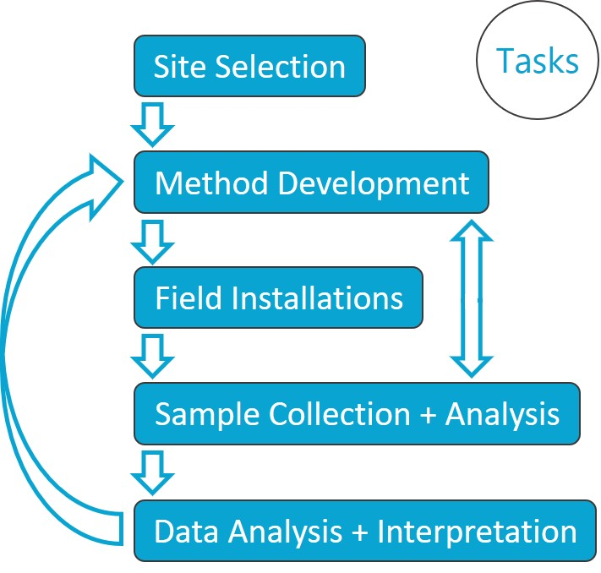

Masters thesis task flowchart

## Research sites

Six sites were selected across the Leech Water Supply Area. The six research sites represent five nested catchments and the entire water supply area basin defined from the point of (future) diversion, the Leech Tunnel.

|  |  |  |  |  |
| --- | --- | --- | --- | --- |
| Site Number | Site Name | Characteristic | Drainage Area (km2) | Elevation (m a.s.l) |
| 1 | Weeks Outlet | Wetland-draining headwaters | 16.1 | XX |
| 2 | Chris Creek | Headwaters | 9.6 | XX |
| 3 | Leech Head | Mainstem river head | 26.2 | XX |
| 4 | Cragg Creek | Mainstem river | 37.1 | XX |
| 5 | West Leech | Mainstem river | 35.2 | XX |
| 6 | Leech Tunnel | Future diversion point | 98.7 | XX |

_*Sites 1 and 2 monitor subcatchments of the site 3 drainage area._

Note that Strahler order was used to define stream orders, such that a headwater creek is assigned first order, and the confluence of two headwater streams creates a second order stream, two second order streams join to become a third order, and so on (i.e headwaters are lowest number, mouth is highest).

#### 1. Weeks Outlet

Jordan Meadows wetland is located in the northwest of Leech River watershed, it drains to the east and joins the outflow of Weeks Lake (south end of the lake). The wetland and lake outflow streams join and flow east to Research Site #1, “Weeks Outlet”, which is a third order stream (Strahler) of the western headwaters of Leech River. This research site has a drainage area of approximately 16 km2. The channel is fairly straight and bed material is primarily silt/clay. The water at this site was noteabley tannin-coloured. This research site was located about 0.4 km west (upstream) of the confluence with Chris Creek.

A large culvert upstream of the monitoring site was replace with a bridge in August of 2019. The culvert had been perched above the streambed level and was obstructing the movement of fish and water flow. Prior to the culvert removal, several groundwater seeps were observed downstream; these seeps maintained base flow of summer waters in this low-relief stream reach. There were high levels of iron (above guidlines for aesthetic objectives) in the water downstream of the culvert, possibly due to culvert rust.

![](images/XXXXX.jpg){width=50%} ![](images/YYYY.jpg){width=50%}

#### 2. Chris Creek

Chris Creek is the western headwaters of Leech River. This research site is approximately 0.2 km east (upstream) of the confluence with the Weeks Outlet stream. The study site on Chris Creek monitors waters draining from approximately 9.6 km2 of forested land, including a small lake (Worley Lake). The monitoring site of Chris Creek was downstream of a bridge, on a slightly sinuous reach with boulders and bedrock dominated morphology and turbulent cascading step-pools. There is a brige that passes over Chris Creek and a large collection of coarse woody debris downstream of the bridge, upstream of the monitoring site.

![](images/XXXXX.jpg){width=50%} ![](images/YYYY.jpg){width=50%}

#### 3. Leech Head

Research site 3 was approxiamtely 1.4 km downstream of the confluence of Weeks Outlet stream and Chris Creek. The “Leech Head” study site was in a deep pool between riffles, it’s a 4th order stream with predominantly Schist bedrock and fairly low relief (~2%) and relatively straight morphology. The water at this site was often coloured by tannins (likely from the Weeks outlet stream contributions). There once was a logging bridge across the river at this site, and some rip-rap remains on either bank.

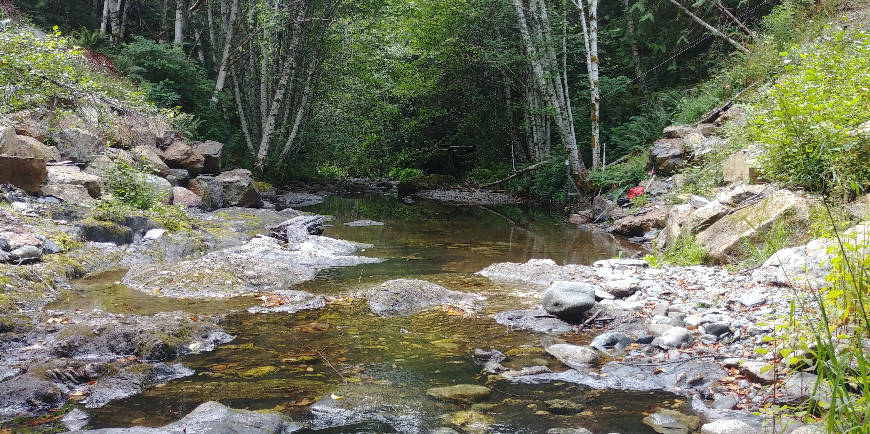

#### 4. Cragg Creek

Cragg Creek is a mainstem river that originates in the east of the Leech River watershed. Cragg Creek is a 4th order stream and this research site location has a drainage area of approximately 37 km2. The Cragg Creek research station was installed upstream of a road bridge, at a CRD hydrological monitoring site (installed over the span of this thesis project). The bed morphology at this site is Schist bedrock and the stream is straight channel with fairly high width-to-depth ratio. Upstream of the bridge Cragg Creek flows turbulently along a low slope, and downstream of the bridge it cascades into several deep pools. From the Cragg Creek research site, the river flows approximately 4.5 km through a steep revine to confluence with the Leech River (this confluence is around 6 km downstream of the Leech Head site, site #3).

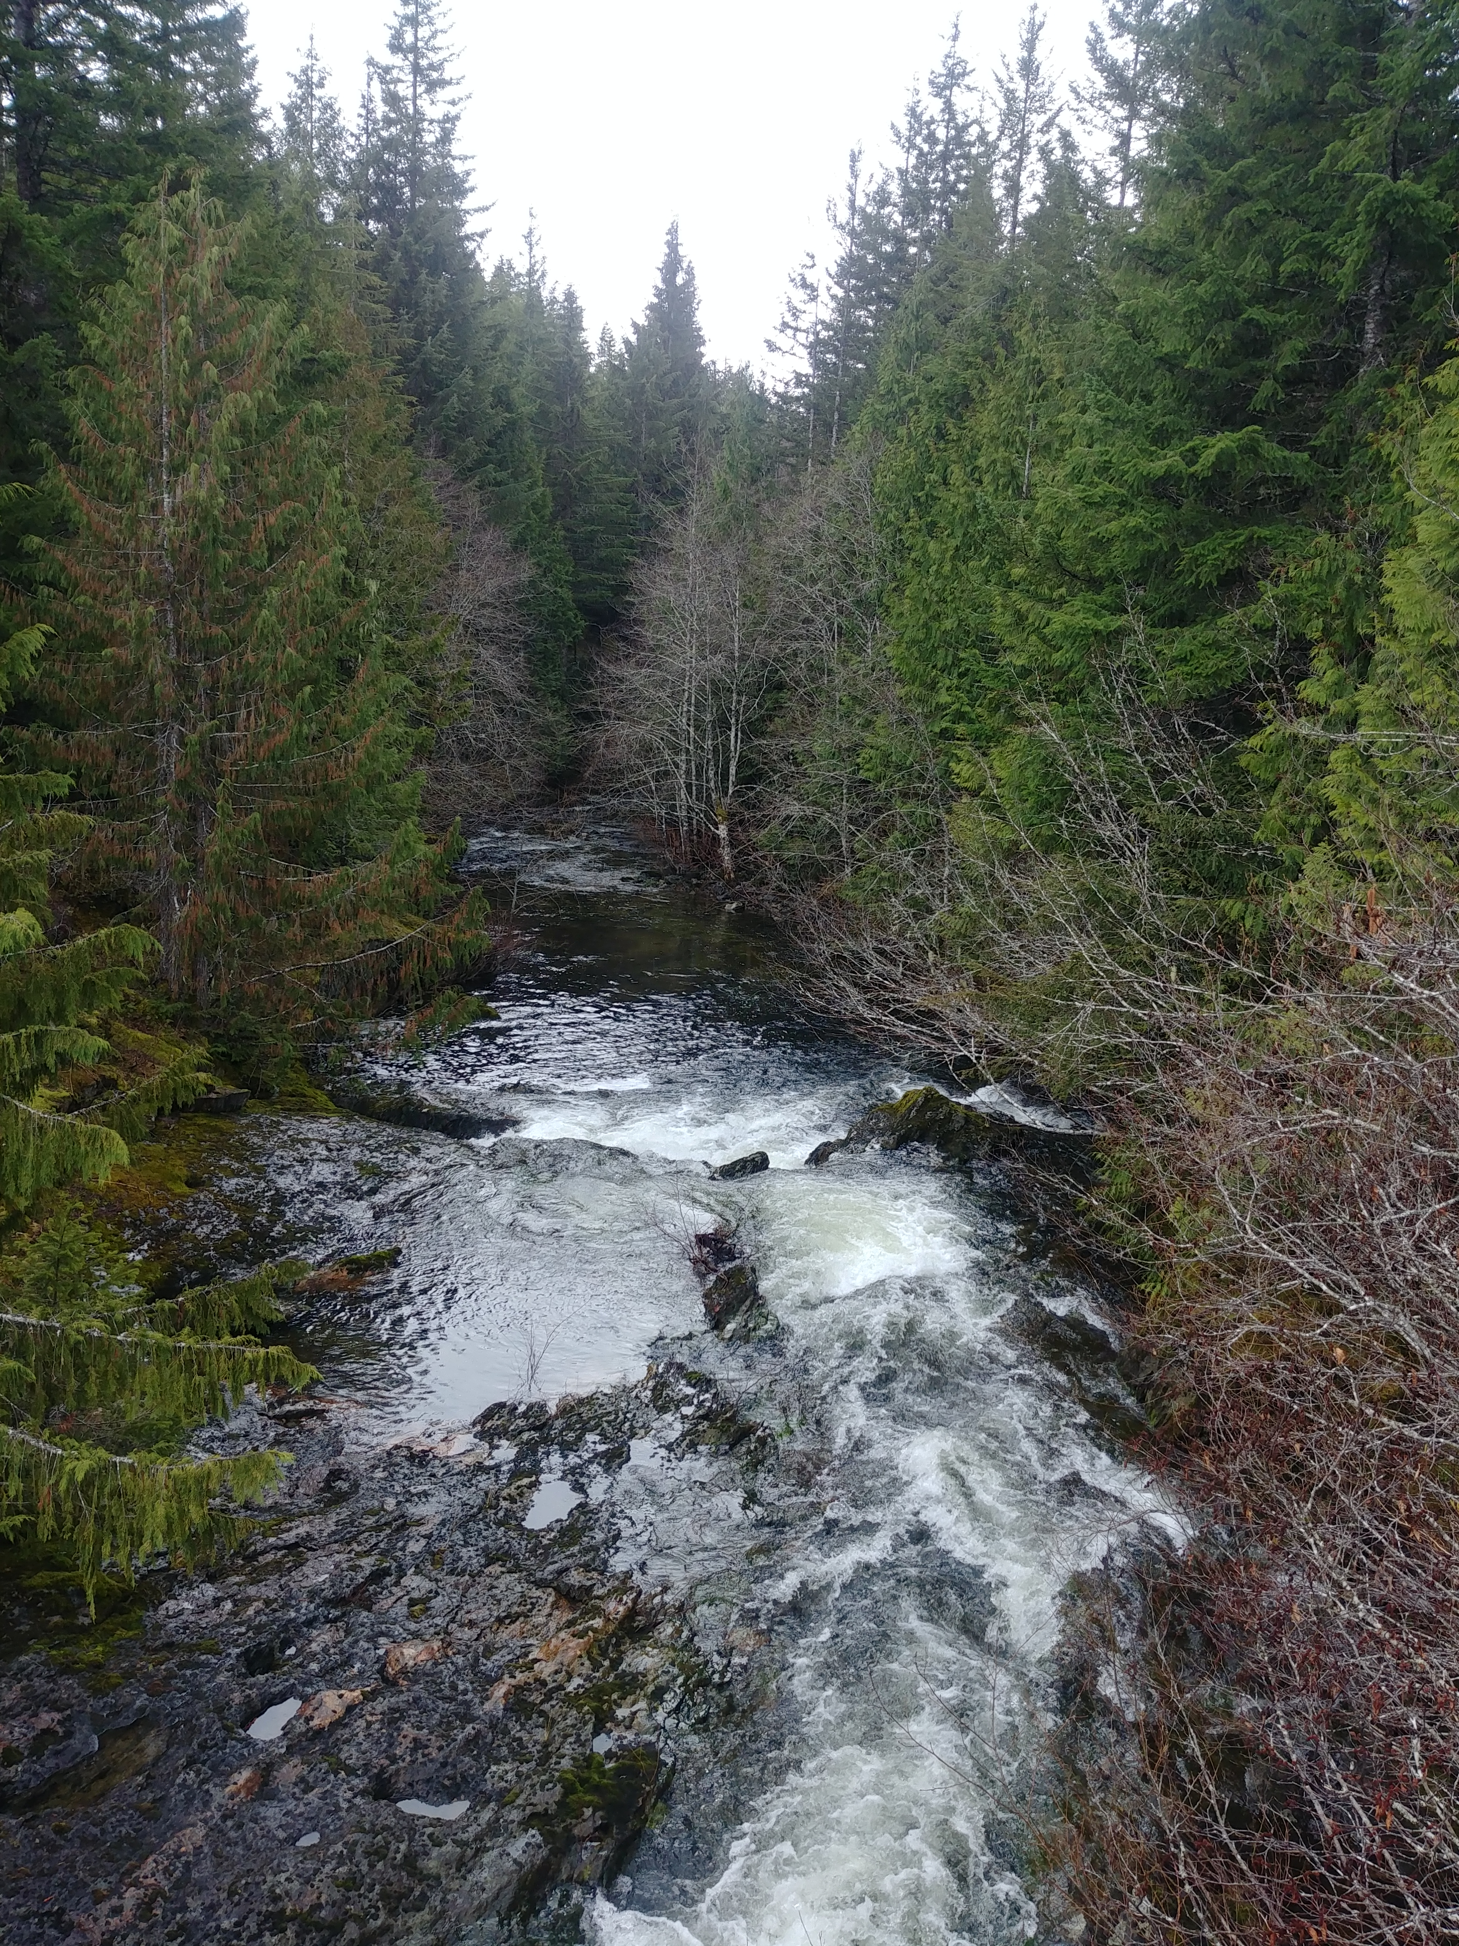 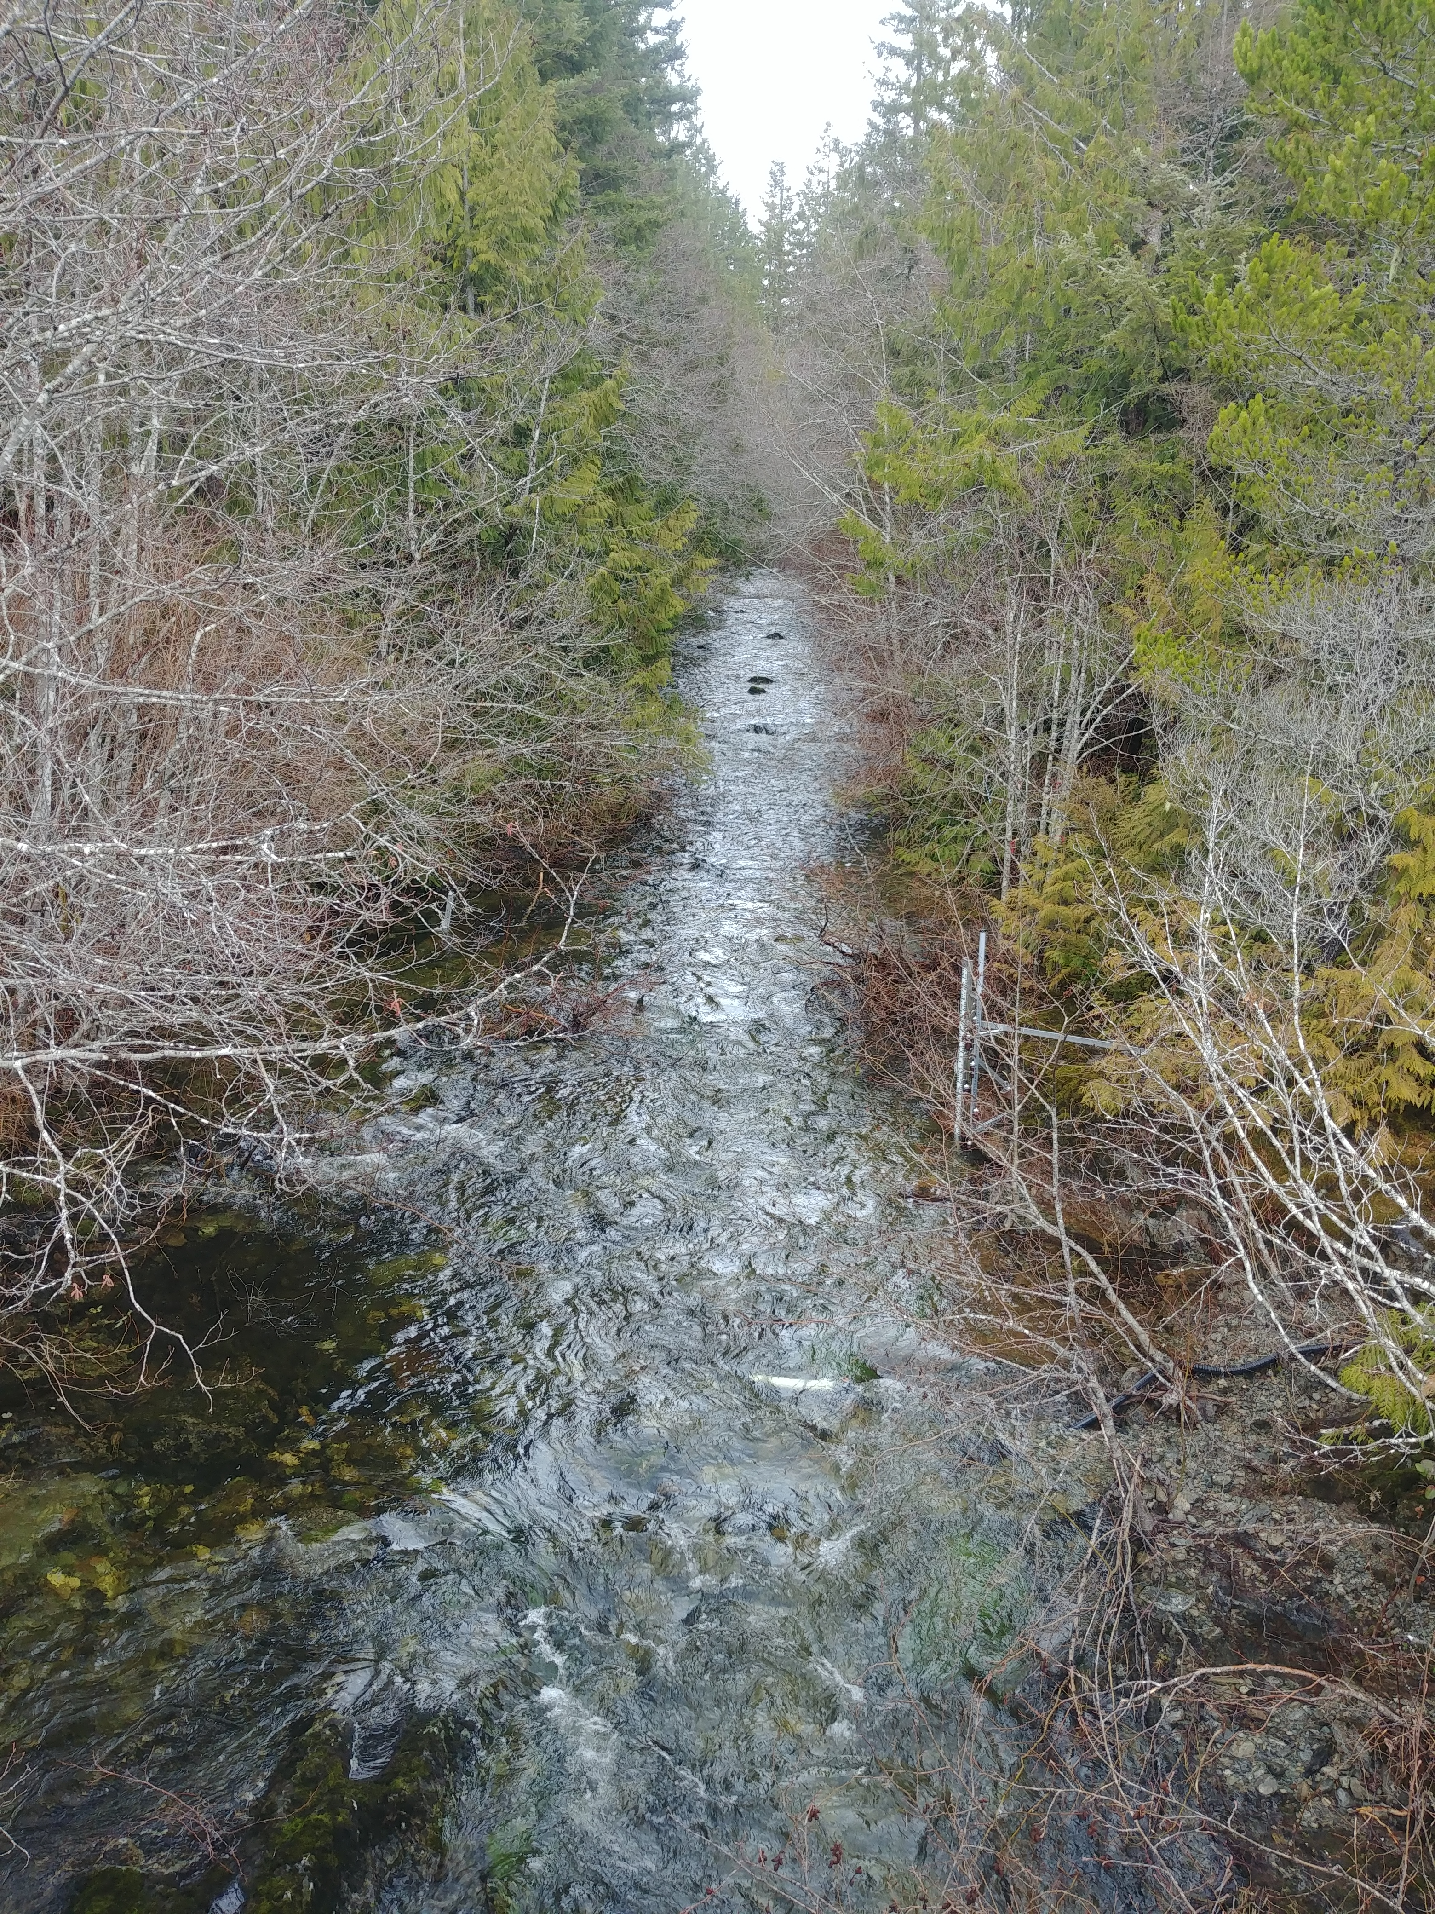

#### 5. West Leech

Originating in the west of the Leech River watershed, West Leech River is a 4th order mainstem river. The West Leech research site monitors a drainage area of approximately 35 km2. This reasearch site has boulder and bedrock substrate, fairly straight channel with relatively high width-to-depth ratio and pool-riffle morphology. The West Leech site is approxiamtely 120m upstream of the confluence with Leech mainstem (~1.5km downstream of the confluence of Cragg Creek with Leech River).

#### 6. Leech Tunnel

This research site is at the point of future diversion, the Leech Tunnel. The Leech River is 5th order, and this research site has a drainage area of approximately 99 km2. The streambed here is dominated by Schist bedrock and boulders. The bedrock in the center of the channel is deeply incised, but overall the river is wider than is is deep. The Tunnel site is approximately 1km downstream of the West Leech confluence.

![](images/XXXXXXX.jpg){width=30%, style="float:left; padding:10px"}

# Sampling Methods

## Vertical racks for passive water sampling on the rising limb of hydrograph

### Theory

### Design

### Benefits, challenges and assumptions

### Field protocol

### Method QA/QC: rising limb sampler quality assurance and quality control

#### Assumption validation: rack samples are stable from collection to retrieval and analysis

##### Temperatures (above and below water on racks)

##### Hold-time experiments

#### Assumption validation: samples collected are discrete (no subsequent mixing)

##### Rising limb sampler discretion analysis

## Development of a passive water sampler design for the falling limb of hydrograph (falling limb sampler)

### Theory

### Design

### Benefits, challenges and assumptions

### Field protocol

### Method QA/QC: falling limb sampler quality assurance and quality control

#### Assumption validation: samples collected are discrete (no premature infiltration)

##### Falling limb sampler discretion analysis

# Analysis

## In the field: gauging streamflow

### Cross-sectional area and velocity

#### Weeks Outlet

### Manning’s equation

#### Leech Head

### Salt dilution

#### Chris Creek

#### Cragg Creek

#### West Leech

## In the laboratory: measuring water quality parameters

### Quantitative analytical methods for dissolved organic carbon

#### Direct via catalytic combution: non-purgeable organic carbon (Shimadzu TOC-V)

#### Proxy via spectrophotometry: optical absorbance (Scan Spectrolyser)

### Qualitative analytical methods

#### Molecular character of organic matter via fluorescence excitation emission (Horiba Aqualog)

### Ancillary data: contributions from partners

* CRD FWx
  + Chris Creek weather station
  + Martin’s Gulch weather station
* CRD turbidity
* CRD flow (Cragg, Judge, Rithet, Tunnel?)
* CRD metals
* forWater tretability ### Laboratory QA/QC: quality assurance and quality control #### Instrument calibration #### Calibration verification (cal vers)

# Results & Discussion

## Spatial variability: DOC variability across the watershed

### Synoptic grab sampling at ten locations

### Stormflow samples: compare and contrast six sites

## Temporal variability: DOC variability over time and within stormflow

### Seasonal patterns over sixteen months of data

### Stormflow samples: variability within six sites

# Conculsions

## Characterizing the Leech Water Supply Area

## Understanding spatial and temporal variability in hydrochemical dynamics

# Future Directions

* How will source water with higher tannins (i.e Leech River water) affect the primary treatment process of UV disinfection (currently used for Sooke rerservoir water)?
  + What are the operational limits of TOC (or tannins) in source water with respect to UVT system performance?
* Can UVT photodegrade TOC molecules such that DBP-FP is reduced?
* Can UVT be used as a primary treatment to reduce the requirements for chemical filtration and reduce the solid waste generated by coagaulants?

# APPENDIX

## forWater: NSERC Strategic Network for forested drinking water source protection technologies

The forWater Network is a transdisciplinary cross-Canada applied research collaboration focused on the connections between treated drinking water quality and land-use impacts of forest management. The majority of source drinking water originates in forested headwaters, but the connection between upstream forest management and downstream treatment remains poorly understood. Across Canada, forWater researchers are studying water quality in watersheds under a variety of different forest management strategies. Through collaborative analyses, forWater is working to evaluate source water treatability metrics, downstream propagation effects, and resource economic with the ultimate goal of providing a framework for treatement demands as they relate to forest management strategies.

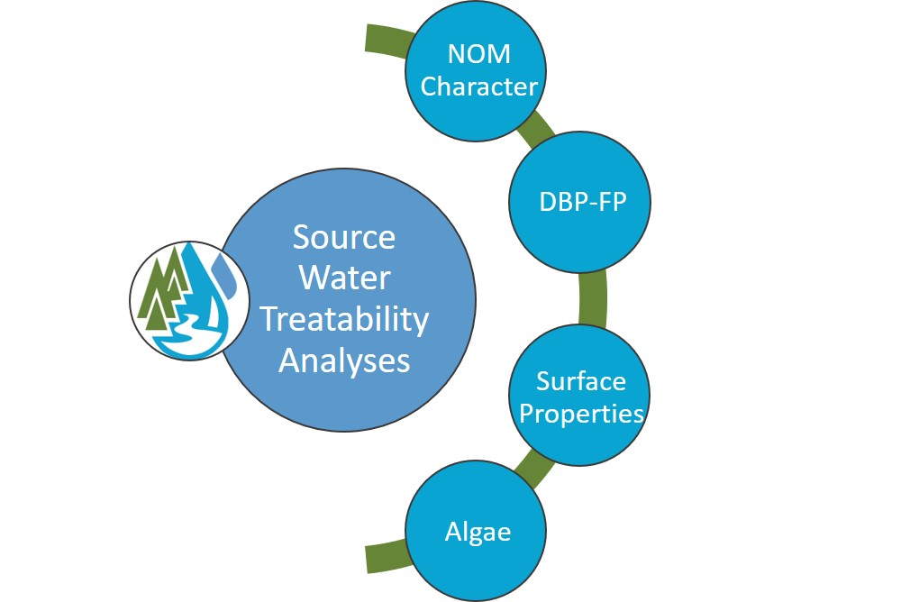

forWater NSERC Network for Forested Drinking Water Source Protection Technologies

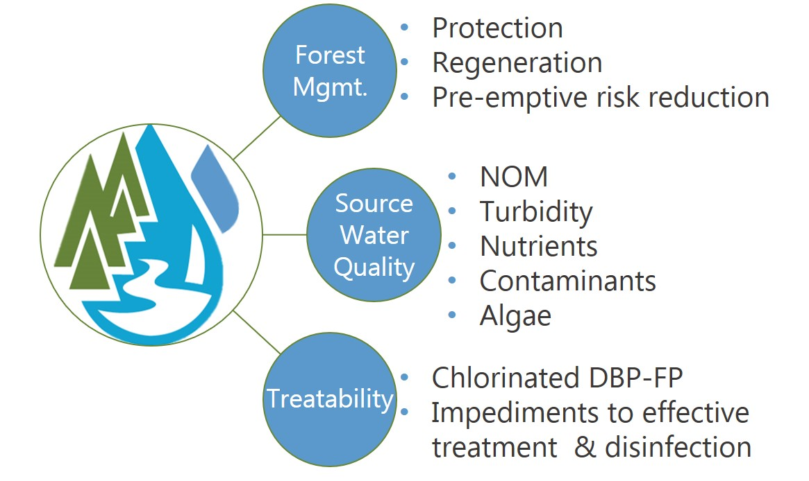

forWater NSERC Network for Forested Drinking Water Source Protection Technologies

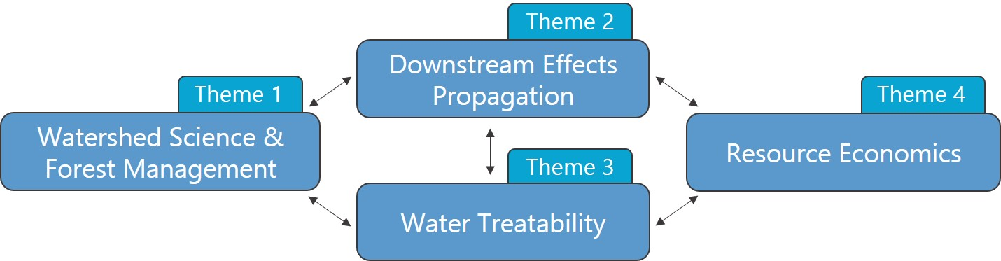

forWater Research Themes

# References

Capital Region District, Integrated Water Services. 2017. “Regional Water Supply 2017 Strategic Plan.” Victoria, B.C.